**Create a Token in your Kaleido Consortium**

*Initial Note:*

*The blockchain digital environment is a very dynamic environment where updates and changes occur frequently. In this program, to carry out the practical activities and give you a real vision of the tools available on the market, web resources and software external to this program are used.*

*For this reason, although we make every effort to keep the guides updated, sometimes the appearance you see of the tools may appear different from the images we show you in this guide and its accompanying documents. Don't worry about the differences you may find. In most cases you will be able to follow the instructions of the activity by easily interpreting the differences between the guide and the real environment, if any. In the case of this not being possible, please let your facilitator know by sending a message through the inbox of the program's platform. The facilitator will help you resolve any questions you may have.*

# **1.- Introduction:**

To use this walkthrough, you must have previously created a consortium in Kaleido. If you have not yet done so, you can use the walkthrough “Creating a Consortium in Kaleido”.

This walkthrough will indicate the options that will allow you to add a token to your consortium without the need for programming by using the “Token Factory” in Kaleido. The factory allows you to choose, among many alternatives, the characteristics that you want for a token.

# **2.- Creating a Token:**

From the main dashboard, select “Digital Assets” from the vertical menu, and then the “Tokens” option.

|  |
| --- |
|   *Img. 1: Tokens Menu* |

Click on “Create Token”

|  |
| --- |
|   *Img. 2: Create Token* |

Kaleido will notify you that you must select an account to deploy your smart contract. Click on “Select Signing Account”.

|  |
| --- |
|   *Img. 3: Deploy Smart Contract* |

You will see the addresses for the contracts for both nodes that we previously created. Choose one and click on “Select”:

|  |
| --- |
|   *Img. 4: Selecting address* |

Now, Kaleido will ask which account you would like to use to deploy the smart contract. Select one and click on “Create Token”:

|  |
| --- |
|   *Img. 5: Selecting account* |

This link will take you to the Token Factory service where new tokens can be created. Make sure that the “Use our Token Factory” is selected and click on “Next”:

|  |
| --- |
|   *Img. 6: Selecting Token Factory* |

It is possible to create ERC20 tokens (fungible tokens) or ERC721 tokens (non-fungible tokens). You must create an ERC20 token. In the “Select Template” drop-down menu, select “KaleidoERC20”. Then, click on the “Next” button. (Note: This step may take a few minutes as the smart contract is generated):

|  |
| --- |
|   *Img. 7: ERC20 Token selection* |

Enter a name, symbol, and total supply for your token. After entering this information, the “Deploy Token Instance” button will be enabled, click on it to run your ERC20 token and wait a few seconds until the contract has been mined into your blockchain network. A “Deployment Successful” message will pop up in the bottom left corner once it has finished. Once you have seen this message, click the “Finish” button to finalize the creation of your ERC20 token.

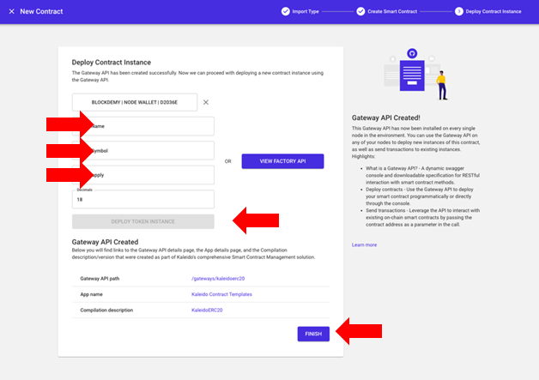

*Img. 8: ERC20 Token*

Finally, go to the main dashboard and select the “Data Explorer” option in the vertical menu, then select Block Explorer -> Dashboard.

|  |
| --- |
|   *Img. 9: ERC20 Token data* |

In the lower section called “Latest Transactions”, select the smart contract for the token you have created. You will be able to see all its details, such as the Hash, Block where it was mined, Contract Details, Gas fees, and Time Stamp.

|  |
| --- |
|   *Img. 10: Latest transactions* |

Click on the transaction you created previously and explore the necessary information to answer question #3 on the question sheet. Then, click the link on the block number and answer question #4.

|  |
| --- |
|   *Img. 11: Selected transaction* |